Logging into Tableau

- Click: https://revupreports.com/

- You will be prompted to sign into office 365

- Login using you’re USERNAME@revupreports.com
  - Example:
    - Alicia Burgess
    - aburgess@revupreports.com
      - (username = first initial + last name @revupreports.com)
    - Your password is the same password you used for VPN

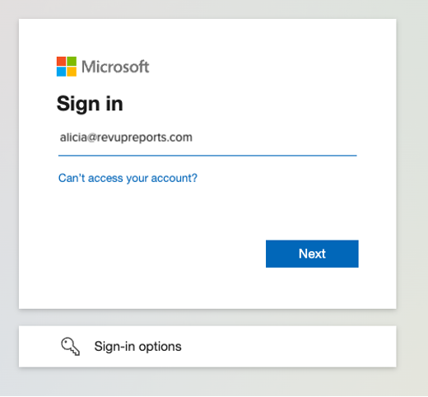
- Enter Password
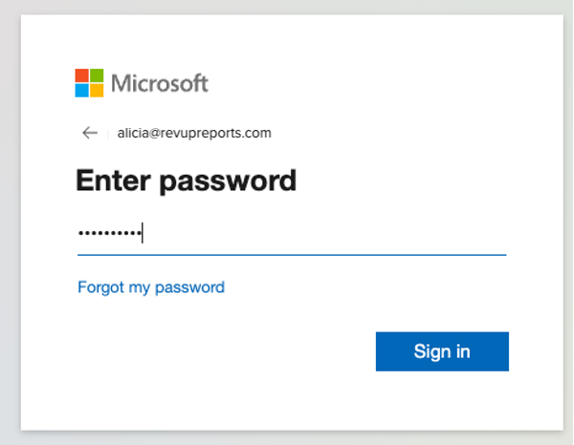

- You will be prompted for additional information.
  - Click “Next”
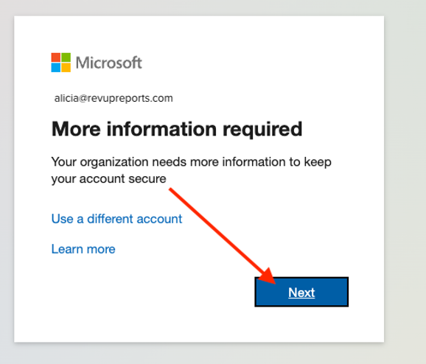
- Enter in your phone number
  - Step 1:
    - Select Mobile Number
      - Select United States
      - Enter Phone Number
        - Click “Next”
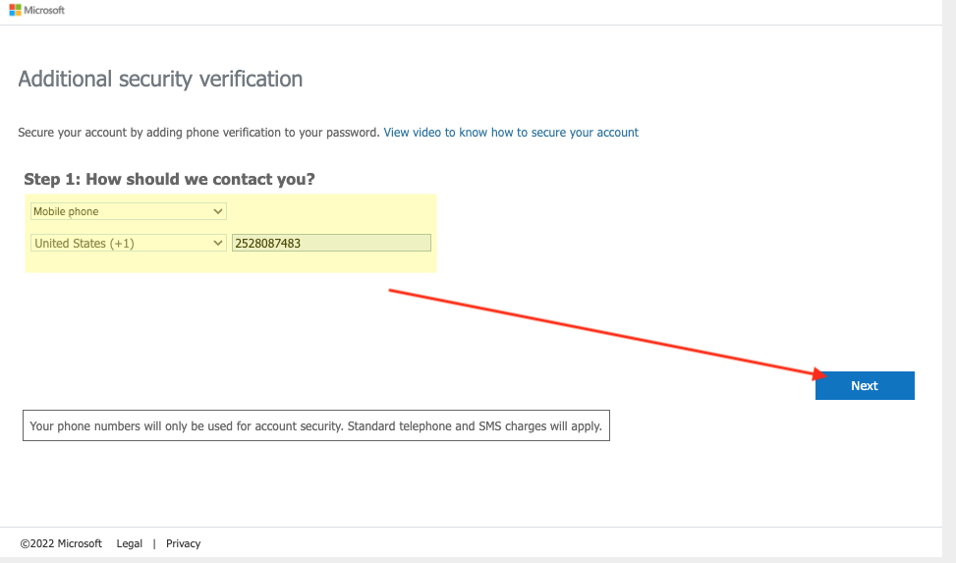

- You will receive a text message with a verification code on your mobile phone
  - Enter the verification code
  - Click “Verify”
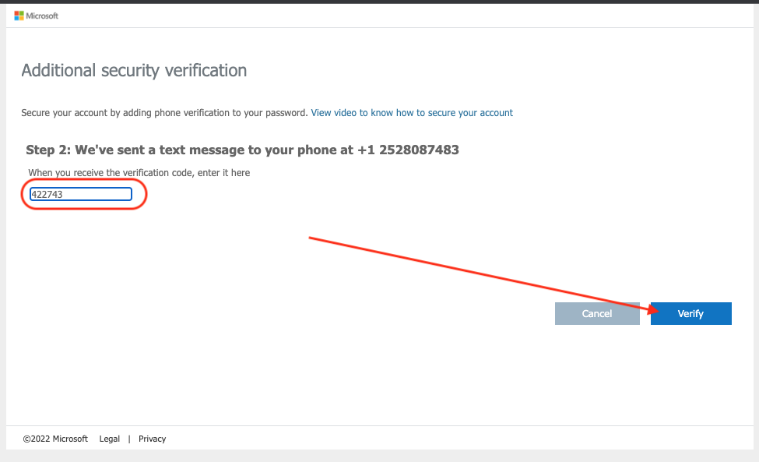
- Once again, you will be prompted for additional information.
  - Click “Next”

- Complete your Security Questions
  - Click “Set them up now”
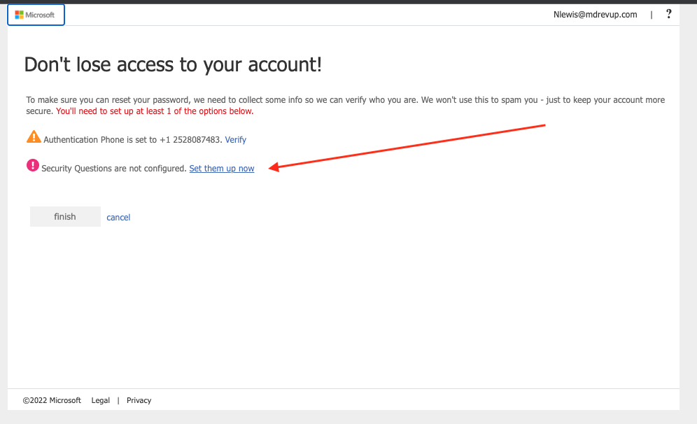
- Answer the security questions
  - Answer each question
  - Click “Save Answerers”
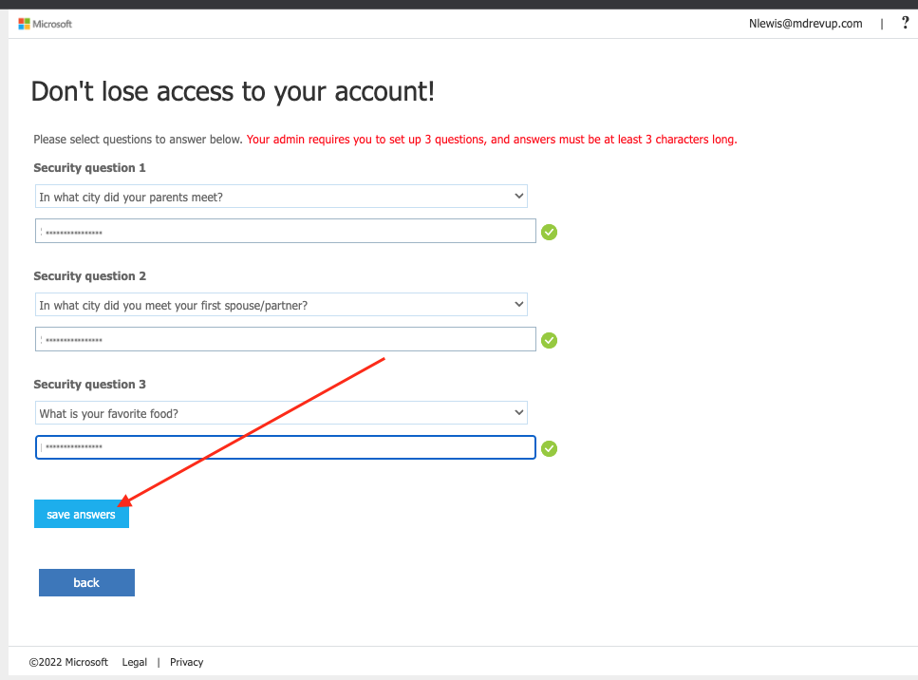

- Click “Finish”
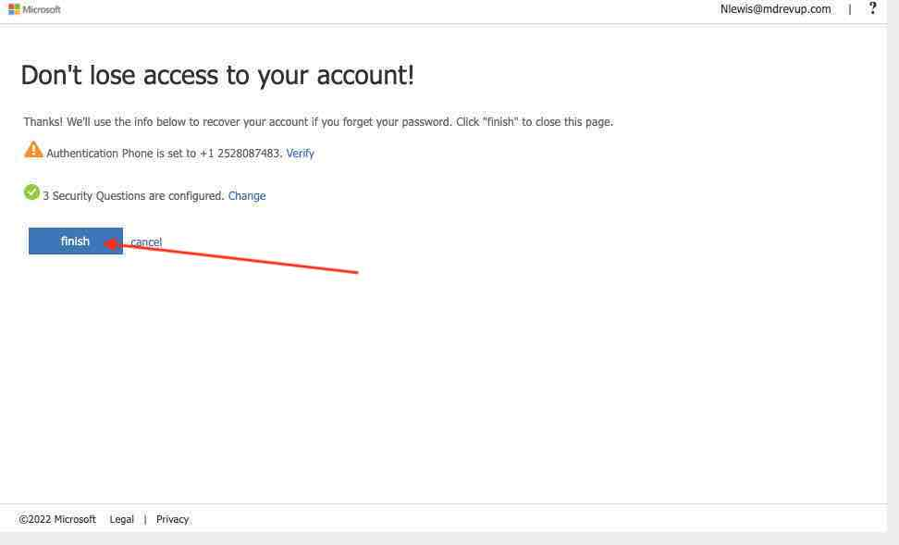
- You will be prompt to grant Tableau access to your account
  - Click “Accept”
Screen Shot 2022-04-28 at 1.43.59 PM
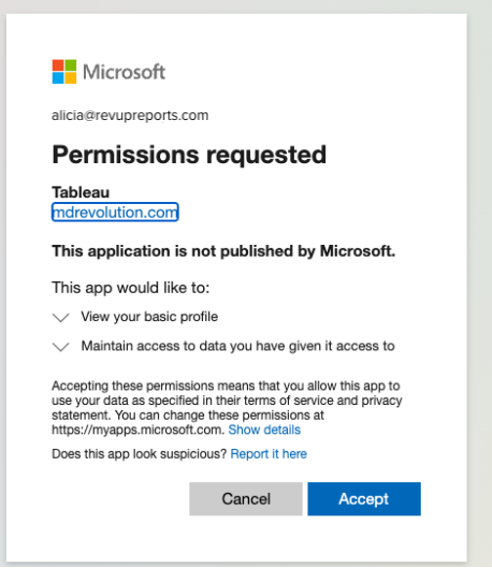
- Login to Tableau
  - Your credentials have not been modified
    - Enter: Your Username
    - Enter: Your Password
      - Click "Sign In"

