Resetting Your Office365 & Tableau Password

Open an Incognito Window in Chrome
- Click the 3 stacked dots
  - New Incognito Window
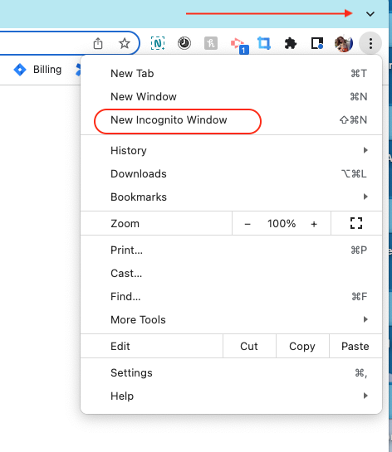
Go to Revup.reports.com
- In your search bar type:
  - https://revupreports.com/#/signin
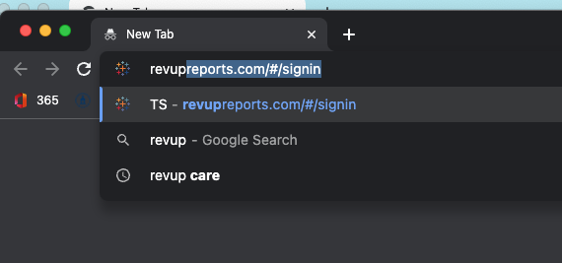
Click “Can’t access my account”
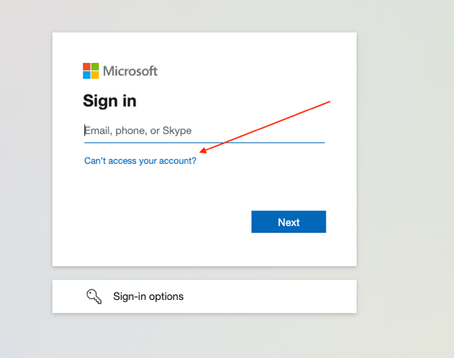

Click “Work or school account”
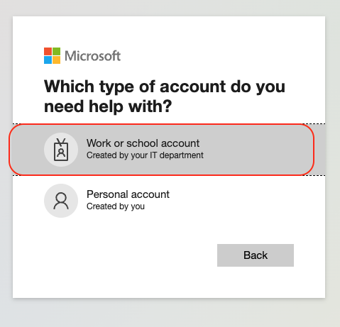
Enter your USERNAME@mdrevup.com
- Your username is (first initial + last name @mdrevup.com)
  - Example: Alicia Burgess = aburgess@mdrevup.com
    - Enter the charters from the picture
      - Then Click “Next”
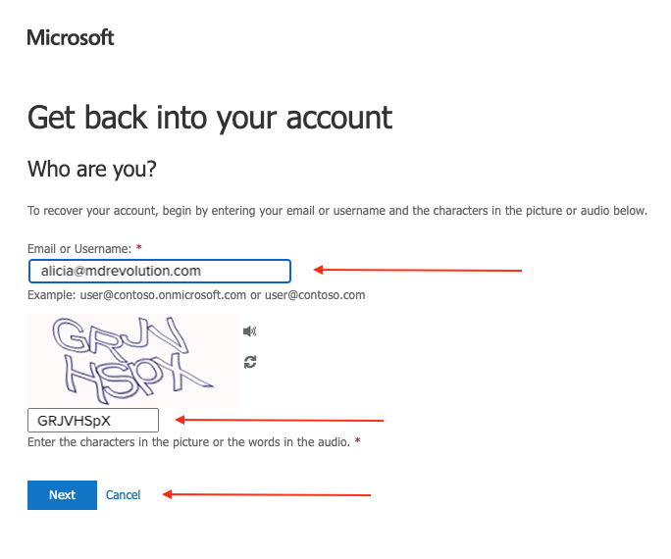

Select your first verification method
- Example:
  - Select “Email my alternative address”
    - Then, click “Email”

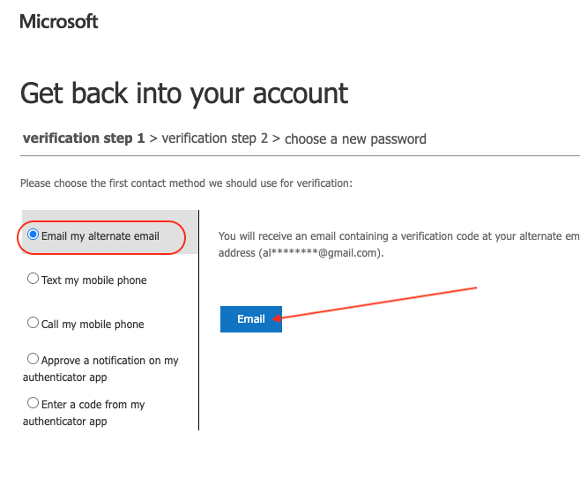
Enter you verification code
- Click “Next”
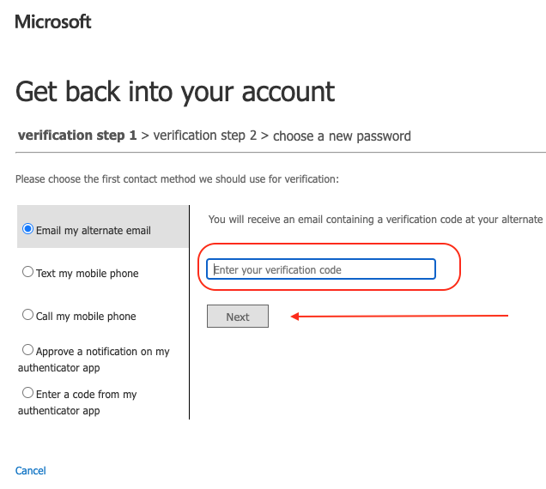

Select your first verification method
- Example:
  - Select “Text my mobile phone”
    - Then, click “Email”

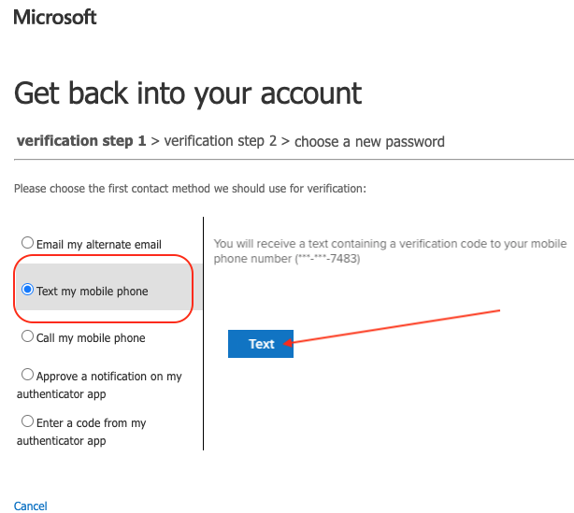

Enter you verification code
- Click “Next”
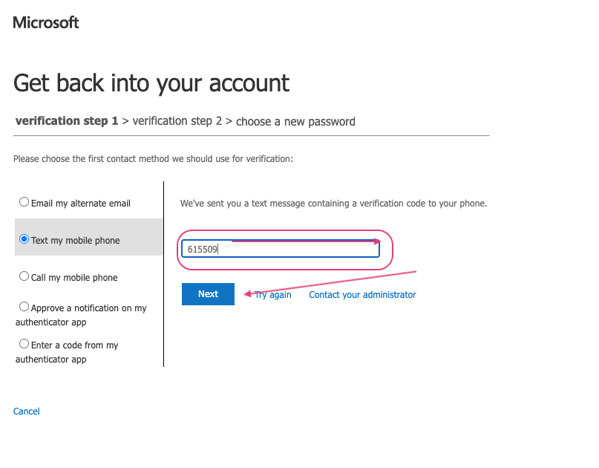

Choose a new password
- Enter your new password
  - Enter it a second time to confirm
    - Click Finish
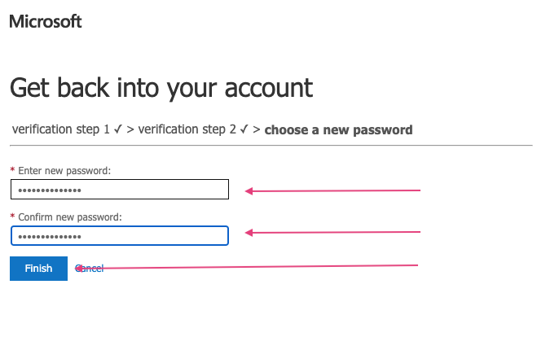
Your password has been reset.
- Click on the “Click here” link to return to the login screen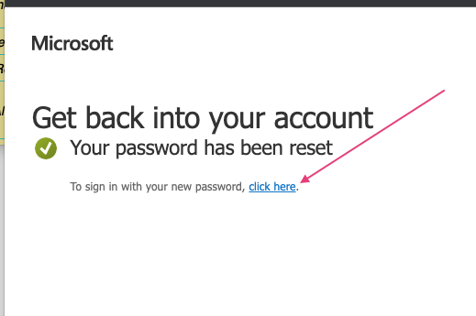

- Enter your USERNAME@mdrevup.com
  - Example:
  - Alicia Burgess
  - aburgess@mdrevup.com
    - (username = first initial + last name @mdrevup.com)
  - Click "Next"
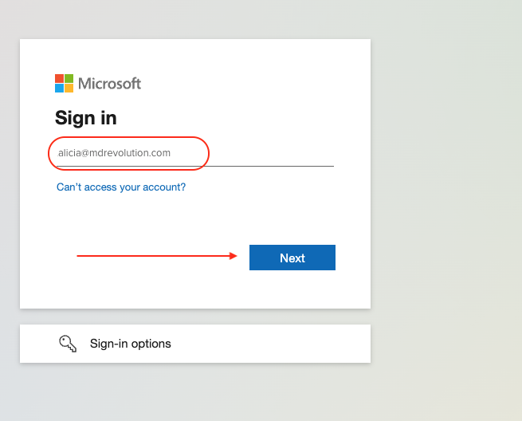
Enter your Password
- Click “Sign in”
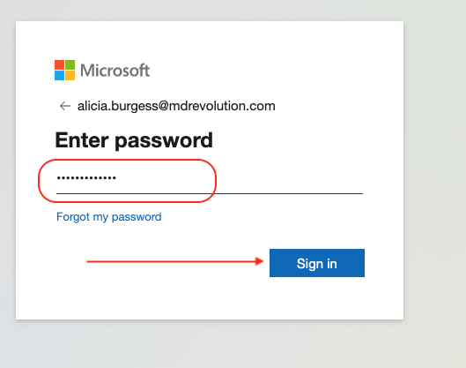

Verify your identity
- Select a method to verify your identity
  - Depending on verification method follow the necessary steps to verify you identify
  - 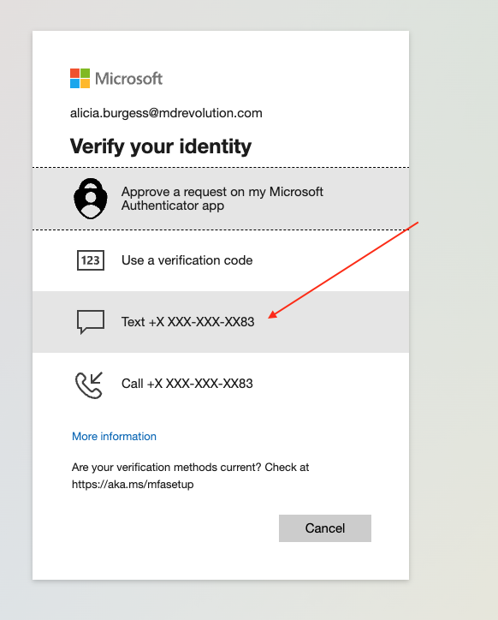

Once verified go to Revup.reports.com
- In your search bar type:
  - https://revupreports.com/#/signin
    - Enter your Tableau Username
    - Enter your NEW password
      - Click “Sign In”
